Proposal for

Beetleweight Combat Robot

Team Name: DKDs

Bot Name: PaltuBot

1. Introduction
This proposal outlines the design, construction, and materials used in building a Beetleweight (1.5 kg) Combat Robot for the Mini Bots Competition. Our design is centered around a single-piece Aluminium-6061 or Aluminium-7075 alloy frame, which provides an optimal balance of durability and lightweight performance. The bot is built for high-speed attacks, strong maneuverability, and durability in combat.

2. Objectives
- Develop a durable and efficient beetleweight combat robot.
- Utilize precision machining and advanced materials for robustness.
- Optimize weapon effectiveness for high-impact damage.
- Ensure mobility, stability, and effective maneuverability in combat.

3. Design Overview
Our combat robot follows a beater-bar spinner design, which is known for its high kinetic energy transfer. The chassis is made from Aluminium alloy for durability and from Ultra-high molecular weight polyethylene (UHMWPE), while the weapon is constructed from aluminum alloy which is of more density than the main body with high-speed motor integration. The frame ensures maximum rigidity while keeping weight within the 1.5 kg beetleweight category.

4. Materials & Structure
- Chassis: Single-piece Aluminium alloy(6061 or 7075) frame for impact resistance and lightweight construction. UHMWPE will be used on the walls, and areas of high impact.
- Weapon: High-speed beater bar, machined from high density Aluminium, with steel shaft and durable bearings, powered by a powerful brushless outrunner motor
(Dimension - 2836, kV rating 1500-2500 depending upon cost constraints)
- Wheels: As the arena will probably have a wooden floor, we will implement metal spiked wheels for better grip, and to avoid slipping. If the arena floor is metal or some other harder material than wood, then we will use Foam Wheels that are excellent at absorbing shock and are incredibly versatile. We can cover it with liquid latex for better grip if it's viable economically.
- If wood arena floor -> metal spiked wheels
- If metal or some hard floor -> foam wheels (with optional liquid
latex covering)
- Internal Mounts: 3D printed mounts, and steel mounts (comes with motor) for secure electronics placement.
- Outer Small Wedge Lifters: Made from Steel and connected to chassis through 3d printed mounts.

5. Mechanical Design
- Weapon Mechanism: High-speed beater bar, direct-driven by a powerful brushless motor(mentioned above).
- Drive System: Two-wheel drive with a low center of gravity for increased stability.
- Modular Design: Easily replaceable beater bar and armor panels for quick repairs.

6. Electronics & Components
- Battery: Orange 11.1V 2200mAh 30C 3S Lithium Polymer Battery Pack(Default battery pack provided by the organisers)
- Weapon Motor: Brushless outrunner motor (2836 3500KV) for high-speed rotation. Alternatively we can use lower kV versions like 2836 ~2500KV or a used refurbished motor
- ESC: 30A brushless ESC for the weapon, 20A brushed ESCs for drive motors.(Rs.1000, Rs.600)
- Drive System: Two high-torque brushed DC motors (22mm planetary gear motors) for independent left and right wheel control.(Rs.1000 for both)(try to cut cost using plastic gears)
- Receiver & Transmitter: FlySky FS-i6X transmitter and FS-iA6B receiver for precise control. (Provided by organisers)
- Failsafe System: Integrated kill switch to comply with safety regulations.
  - Alternative: Build a custom kill switch using a relay module.
  - DIY approach reduces cost while meeting safety requirements.

7. Steering setup
In a dual-ESC setup, one ESC controls the left motor, and the other controls the right motor. To achieve proper steering, the transmitter’s channel mixing feature is used to combine throttle (forward/reverse) and steering (left/right) inputs before sending signals to the ESCs.
- Throttle Channel (CH1): Controls forward and reverse motion equally for both motors.
- Steering Channel (CH2): Adjusts the speed difference between the two motors to enable turning.
- Assign the Master and Slave Channels:
  - Master: Throttle Channel (e.g., CH1)
  - Slave: Steering Channel (e.g., CH2)
- Set Mix Ratios: Configure the mix percentages so that:
  - When moving forward, both motors get equal throttle.
  - When steering, one motor speeds up while the other slows down or reverses.
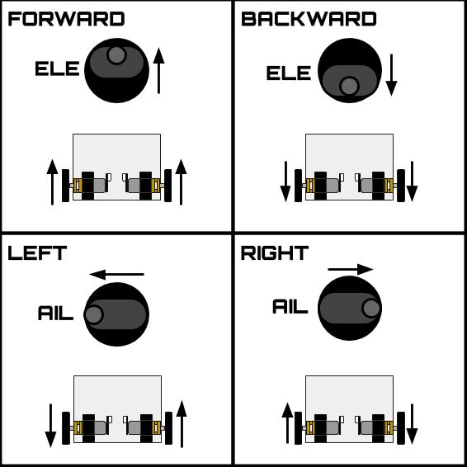

Example Mixing Logic
If the throttle (T) and steering (S) inputs range from -100 to +100:
- Left Motor Output = T + S
- Right Motor Output = T - S
This ensures that:
- Full throttle moves both motors forward.
- Full left steer slows/stops the left motor and speeds up the right motor, causing a left turn.
- Full right steer slows/stops the right motor and speeds up the left motor, causing a right turn.

Benefits of Channel Mixing for Dual ESC Steering
✅ Eliminates the need for additional onboard mixing hardware.
✅ Provides smooth and proportional control for differential steering.
✅ Allows fine-tuning through transmitter settings for optimized handling

Setting Up the Electronic System for Motor Control

1. Introduction
The key components include:
- Electronic Speed Controllers (ESCs) – To control the motors.
- Battery Elimination Circuit (BEC) – To regulate power for the receiver and other low-voltage electronics. The built-in BEC in the ESC could be used as well.
- Receiver – To receive control signals.
- Power Distribution – Managing connections between the battery, ESCs, motors, and auxiliary components.

2. Understanding the Components

a. Electronic Speed Controller (ESC)
The ESC (Electronic Speed Controller) is responsible for regulating power from the battery to the motor. There are two main types:
- Brushed ESC – Controls DC motors.
- Brushless ESC – Used for brushless motors.
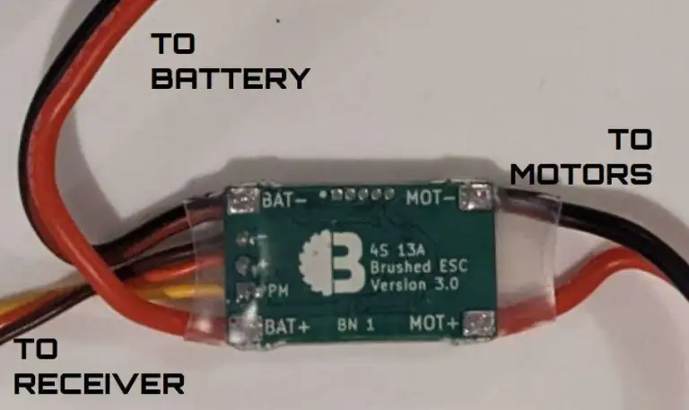
📌 Key connections on a brushed ESC:
- BAT+/BAT- – Connects to the battery.
- MOT+/MOT- – Connects to the motor.
- PPM Input (Receiver Wire) – Connects to the signal pin of the receiver.
🔹 The image shows a 4S 13A Brushed ESC, meaning it supports up to 4 LiPo cells (≈16.8V max) and 13A of current draw.

b. Battery Elimination Circuit (BEC) (Optional)
The BEC is used to regulate voltage for the receiver and other low-power electronics. This is important because our receivers operate at 4V to 8V, while the main power source in our setup is ~11.1 V. The builtin BEC from the ESC could also be used to power the receiver.
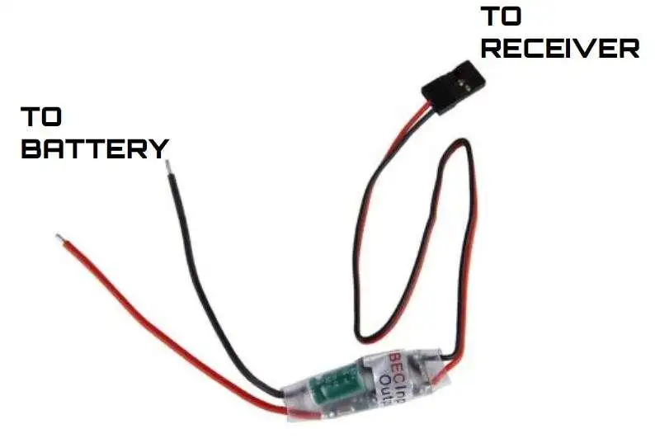
📌 Key connections on a BEC:
- Input (Red & Black wires) – Connects to the battery.
- Output (Red/Black with servo connector) – Provides regulated voltage to the receiver.
💡 An external BEC may not be needed unless extra power stability is required.

c. Receiver
The receiver is where signals from the remote controller are processed. It connects to the ESCs, servos, and other electronic components.
📌 Receiver connections:
- Channels (CH1, CH2, CH3, etc.) – Each channel corresponds to a control input (e.g., throttle, steering).
- Power input (5V & GND) – Supplied by the BEC.

d. Motors
- Brushed Motors – Connected to brushed ESCs.
- Brushless Motors – Require a three-wire brushless ESC.

3. Wiring
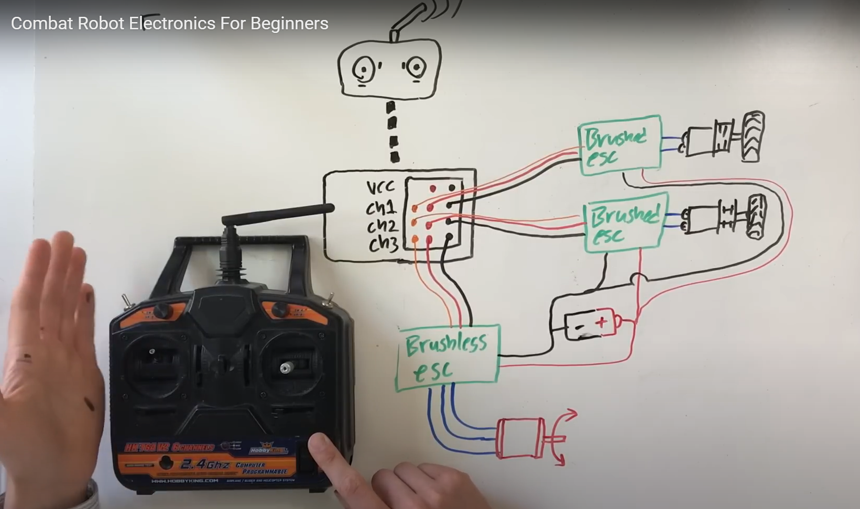
This diagram shows a basic two-motor setup powered by a LiPo battery:
- Two ESCs are controlling two brushed motors (drive motors).
- A BEC (from ESC) is used to regulate voltage for the receiver.
- A power LED is added to indicate the system is on.
- The BEC powers the receiver, preventing high voltage from damaging it.
- The ESCs connect directly to the receiver for signal input while drawing power from the main battery.

Modified Wiring Setup with weapon motor:
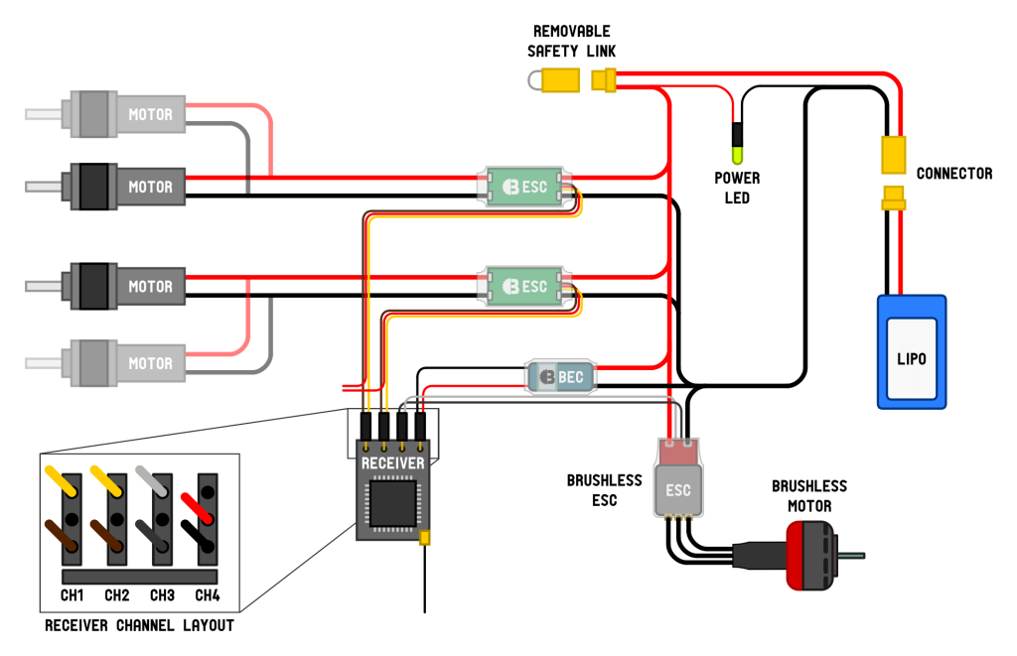
- The red and black lines act as a power rail distributing battery voltage.
- The brushless ESC requires a three-wire connection to a brushless motor, unlike the two-wire brushed ESCs.

4. Step-by-Step Assembly Process

Step 1: Connecting the Battery
Connect the battery’s red (positive) and black (negative) wires to the power distribution rail.

Step 2: Connecting the ESCs
- Brushed Motors – Connect MOT+ and MOT- to the motor terminals.
- Brushless Motors – Connect the three-phase wires from the ESC to the motor.

Step 3: Wiring the BEC
- Connect the BEC input to the battery (same as ESC).
- Connect the BEC output to the receiver’s power pins (5V & GND).

Step 4: Connecting the Receiver
Plug each ESC’s signal wire into a separate receiver channel.

Step 5: Safety & Power Indicators
- Add a removable safety link to quickly disconnect power.
- Install a power LED to indicate when the system is active.
8. Budget Estimation
Component | Estimated Cost (INR)
Single frame body of aluminum or UHMW Slab and Beater for vertical spinner and other polycarbonate for joints | Rs.1500
Motors | Rs.2000
ESCs | Rs.1200-1800
BEC(optional for Receiver, it could be powered by builtin BEC of any motor ESC) | Rs.75
Weapon System Rs.350  (chains and some fittings marked in cad) | Rs.350
Miscellaneous (Wires, Connectors, Fasteners) Rs.300  And kill switch | Rs.300
Total | Rs.5200-5900

9. Conclusion
This project represents a significant step in advancing our skills in robotics, mechanical design, and competitive engineering. With a well-structured plan, high-quality components, and strategic weapon design, our combat robot is expected to perform exceptionally in competitive arenas. We seek funding and support to make this a reality and bring our innovative design to life.

Model Illustrations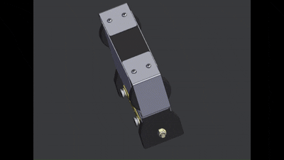
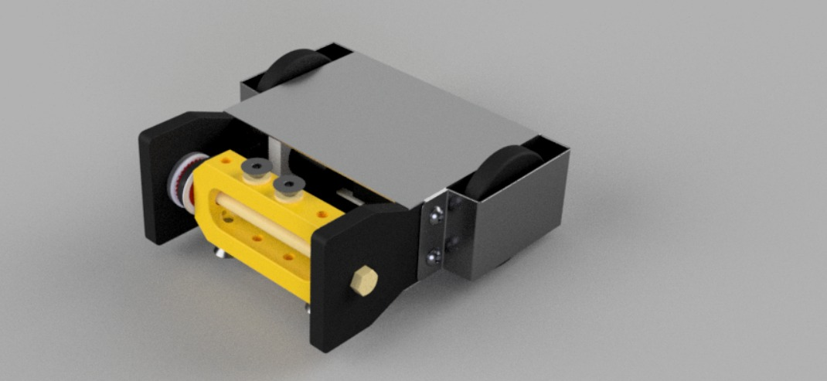
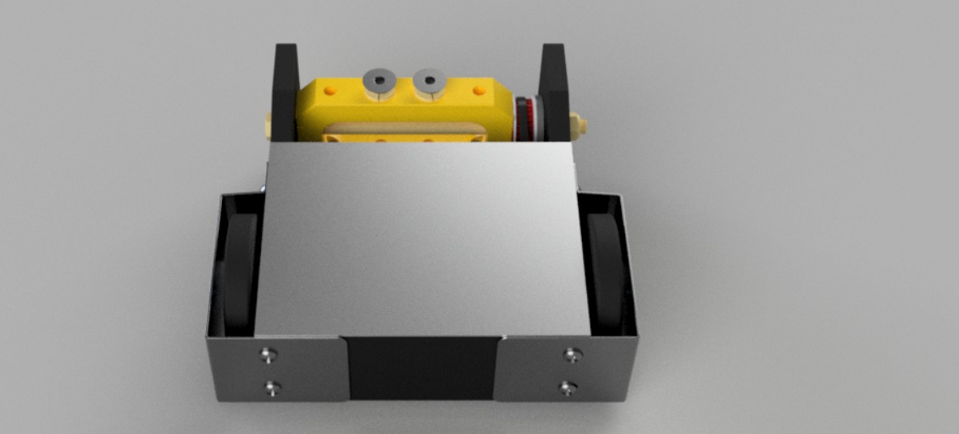
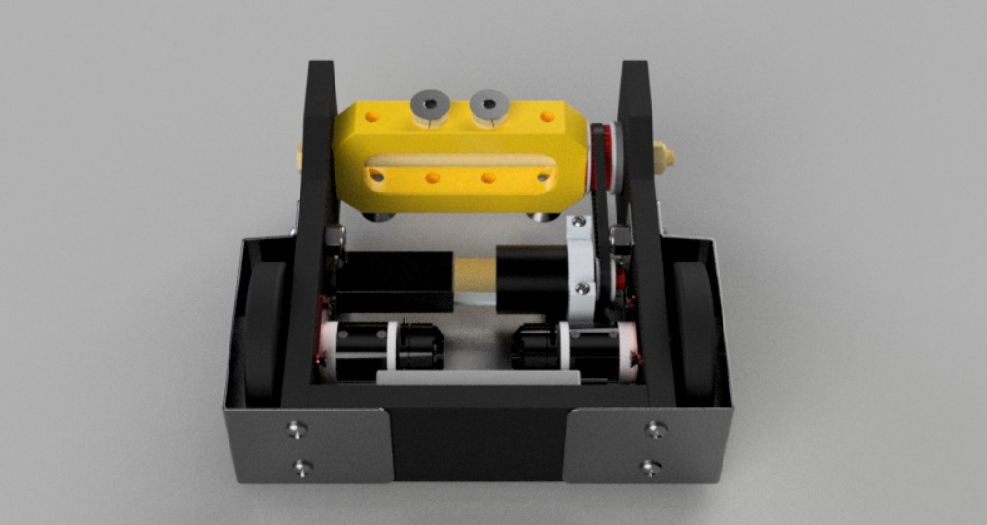

Team Members
- B24033 - Dharmesh Sahu
- B24048 - Utkarsh Ranjan
- B24115 - Arya Mundra
- B24116 - Ayush Pandey
- B24092 - Saransh Goyal

References-
- https://github.com/IainIsCreative/awesome-robot-combat
- https://www.fingertechrobotics.com/proddetail.php?prod=ft-3lb-beater-bar-assy
- https://www.fingertechrobotics.com/proddetail.php?prod=ft-3lb-beater-bar-elec
- https://itgresa.com/product/beater-bar/
- https://buildersdb.com/robots
- https://forum.bristolbotbuilders.com/tag/beetleweight-1-5kg
- https://forum.bristolbotbuilders.com/c/builds/5
- https://forum.bristolbotbuilders.com/c/cad-resources/7
- https://www.instructables.com/How-to-design-and-build-a-combat-robot/
- https://www.deadblow.net/sitemap/
- https://bristolbotbuilders.com/guides/#general_guides
- https://bristolbotbuilders.com/guides/transmitter/
- https://bristolbotbuilders.com/tools/tipspeed/
- https://connbots.weebly.com/blog/category/el-tigre
- https://www.youtube.com/playlist?list=PLS8Mq0vc8p3ITl15fpOhZ-tfmtj6-BxAO
- https://www.flysky-cn.com/fsi6x

